Accessibility Features in the Library Catalog

Search for books, audiobooks, DVDs, & other materials. Find the format that fits your needs!

Finger Lakes Library System
1300 Dryden Road, Ithaca, NY 14850
www.flls.org/accessibility
607-273-4074

Searching the Library Catalog

1. Visit catalog.flls.org or visit your library’s website and access the catalog.

2. You will be presented with a Quick library search. Enter your search term and click Anywhere, Subject, etc. (Image below)
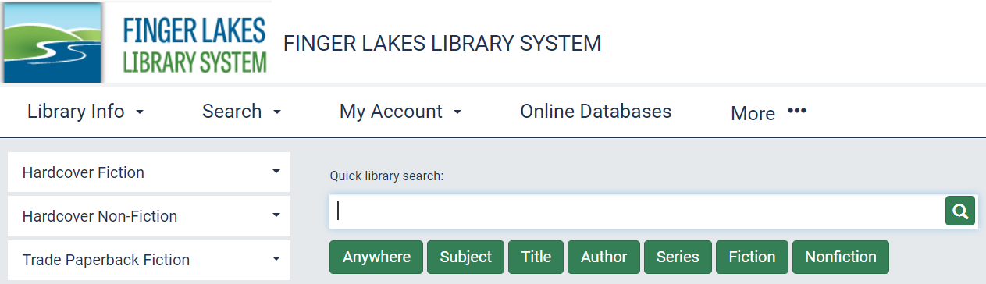

3. To add more search parameters, click on “Search,” then “Keyword” in the menu.

4. To limit the search to a specific format, like “Large Print,” click in the “Limit by” box and click on your selection. (Example image on next page).
5. Click on the search button (red arrow on image below) or hit the enter key on your keyboard.
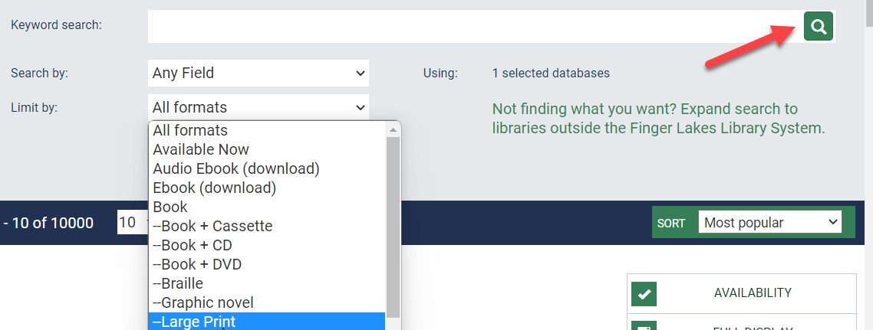

Example: Open a Keyword search and “Limit by” Large Print. Next, type in “Patterson, James” in the search field. This will bring up a list of all the large print books written by James Patterson.

Available Accessible Formats:

= Large Print
= Braille
= Digital Audiobook
= Audio Book on CD
= eBook
= Playaway

Understanding the Search Results

Click “Availability” or “Full Display” to see more information about an item.

“Availability” shows whether the item is checked in and if it is owned by your library.

To get an item that is checkout out or at another library, click “Place Hold.”

Have questions? Please ask a staff member for help—they’ll be glad to assist you.

Enlarging the Screen Text

While using the catalog you can enlarge the text by clicking on the “Large Text” button in the upper right corner of the screen.

You can also magnify most browser screens at any time by pressing the CTRL and + [plus sign] keys on your keyboard.

For additional information and helpful links, visit:
www.flls.org/accessibility

Updated June 2024

